You will correct the mistakes documented in this document,

1. you must check the text under the card and the explanation text box as seen below. These 2 do not match. If they do not match - they have to be aligned.

For those that are not aligned you will create a file and tabulate results

card id and name = card text = explanation text = the alignment text ( this will be provided by ME )
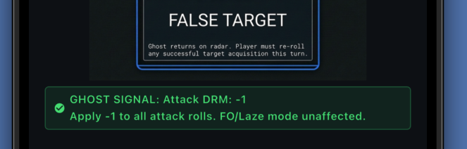

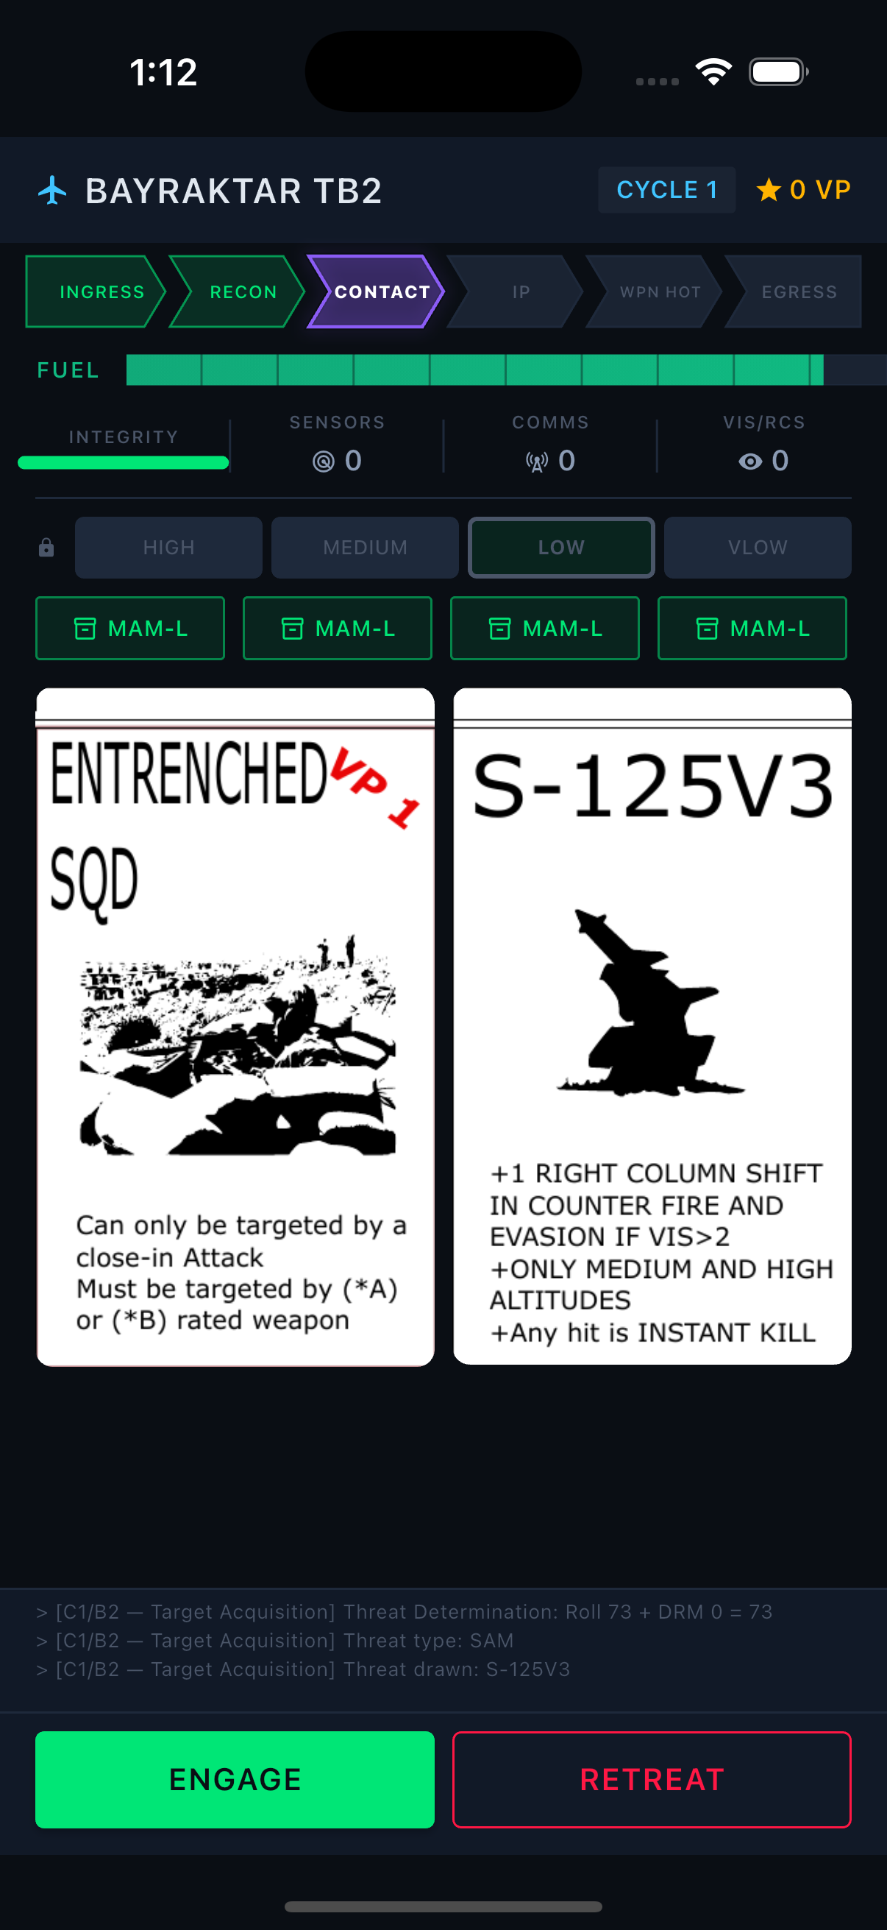
2. In this screen the following must be applied

a. Box the items under the fuel gauge : integrity – sensors – comms and vis/rcs.
b.

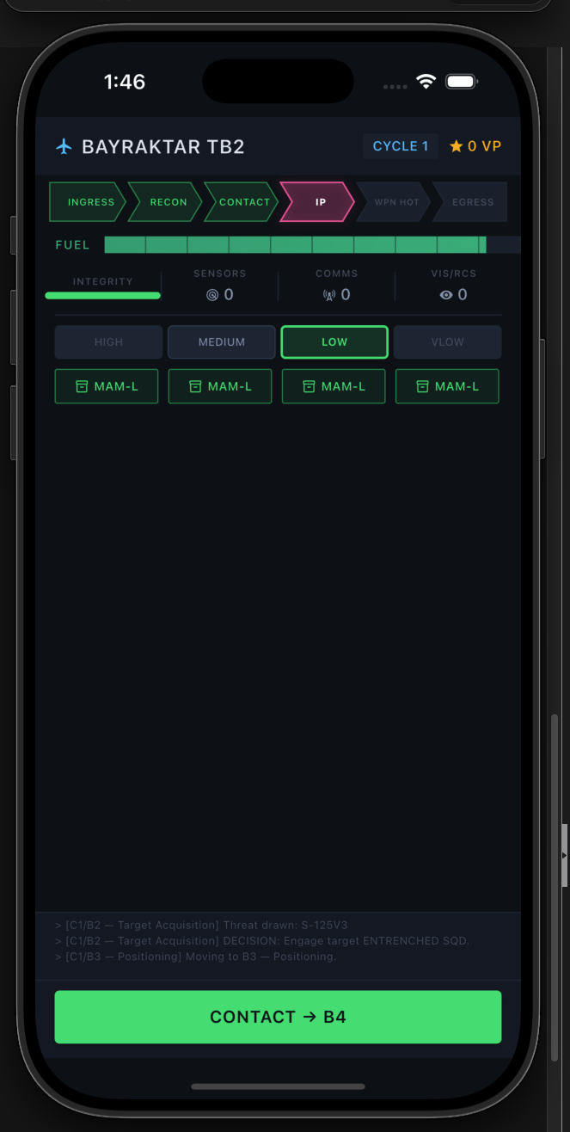

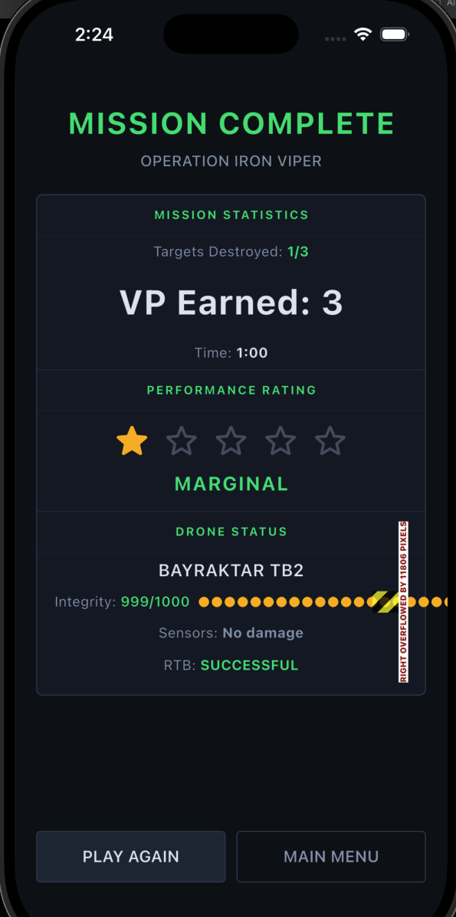

a.

